STELLA SUPPORT
Insights Mobile — Support Playbook
How the app works, what to tell dealership staff, and where to escalate.
Covers MVP Phase 1 · Prepared August 2026 · Internal use — STELLA Support Team

How to use this playbook
This is a reference for STELLA Support when helping dealership staff (Service Managers, advisors, and other Insights Mobile users) with the mobile app. “Customer” in this document always means the STELLA customer using the app — i.e., dealership staff — not the driver whose car is in for service.
Each section below covers a part of the app in the order a user actually moves through it: sign-in first, then the four tabs, then account settings. Every section ends with the specific things to say (and not promise) when a customer calls in.
BEFORE YOU TROUBLESHOOT
This playbook describes the app as built in the current MVP Phase 1 release. If a customer describes behavior that doesn't match a section here, treat it as a possible regression or environment issue and escalate per the “Escalation Path” section at the end — don't guess.

1. App overview & navigation
Insights Mobile gives dealership service staff a mobile view into STELLA's phone-answering performance, the alerts that need a human, two-way texting with customers, and their customer record list.

Navigation model
- Bottom tab bar (always visible): Insights, Conversations, a green voice-assistant shortcut button, Alerts, and Customers. Switching tabs does not keep a back-history — each tab starts fresh, like standard iOS tab behavior.
- Pushed screens: Profile & Account, Notifications, Rooftop Access, an individual Conversation thread, and Compose all slide in with a Back button.
- Bottom sheets (pop-up panels): the Account menu, Sign Out confirmation, Quick Actions, Date Range, Custom Range, and Switch Rooftop. Tapping outside the sheet or its top handle closes it.
- The account/profile avatar (top-right on Insights, Alerts, and Customers) opens the Account menu — this is the fastest path to Profile, Notifications, and Sign Out.

Rooftops and access
A “rooftop” is one dealership location. Staff can be granted access to more than one rooftop inside a dealer group, and can switch between them (or view a consolidated group total) from the building icon on Insights, Alerts, or Customers. All rooftop access is provisioned by the dealer group's own IT administrator through their identity provider — STELLA Support cannot grant or change rooftop access directly. See Section 3 (Sign-In) and Section 8 (Account & Rooftop Access) for what to tell a customer who's missing access.

2. Signing in
This is the area with the most support volume. Read this section in full before taking a sign-in call — most “I can't log in” issues fall into one of four buckets below, and the right fix is different for each.

2.1 How sign-in routes automatically
The app only ever asks for one thing up front: a work email address. There is no “SSO or password?” choice shown to the user — the email domain decides silently:
- A domain with a connected identity provider (e.g. Okta, Azure AD) → the app opens an in-app browser sheet and hands the person off to their dealership's own sign-in page. STELLA never sees or stores that password.
- A domain without a connected identity provider → the app instead asks for a STELLA password, in place, on the same screen.
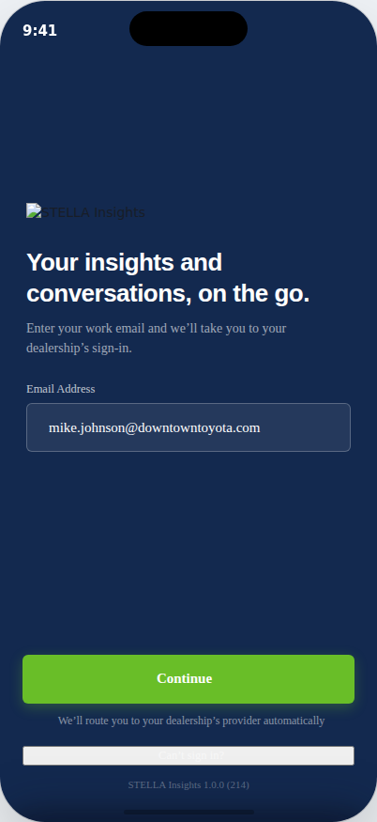
Launch — the only screen before routing happens. One email field, no password/SSO choice shown up front.
SUPPORT TIP
If a customer says “it's asking me for a password I don't have”, that dealership's domain is not connected to their identity provider in STELLA. Don't try to reset an SSO password — direct them to Section 2.3 instead, or escalate to have the domain connected if the dealer group expected SSO.

2.2 SSO sign-in issues
- If sign-in with their dealership credentials fails, that's an identity-provider problem (wrong corporate password, MFA issue, account disabled) — outside STELLA's system. Direct them to their own IT helpdesk.
- If sign-in succeeds but the app then shows “No rooftop assigned yet,” their identity was confirmed but STELLA has no dealership location attached to their account yet. This is an access-provisioning gap, not a login failure.
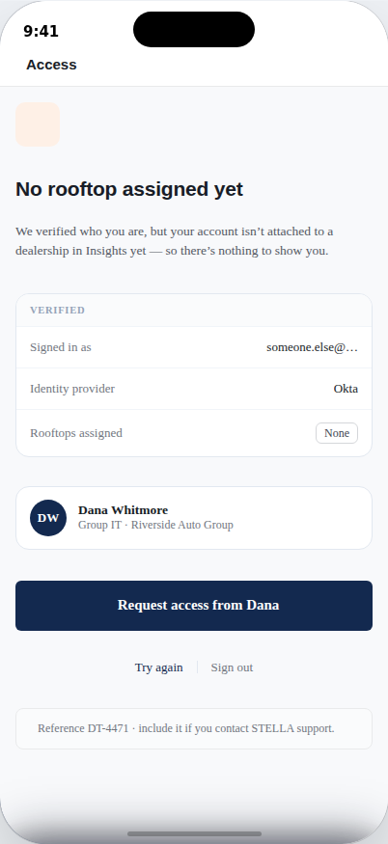
“No rooftop assigned yet” — identity confirmed, but no location provisioned in STELLA.
What to tell the customer:
- Their sign-in worked — this is purely about which dealership location(s) STELLA has attached to their account.
- The screen names their Group IT administrator directly and has a one-tap “Request access” button that notifies that person — have them use it first.
- If they've already requested and it's been more than a business day, escalate to STELLA Support to check the provisioning record. Reference the code shown on their screen (e.g. “DT-4471”) in any ticket — it identifies their specific account/session.

2.3 STELLA password sign-in issues
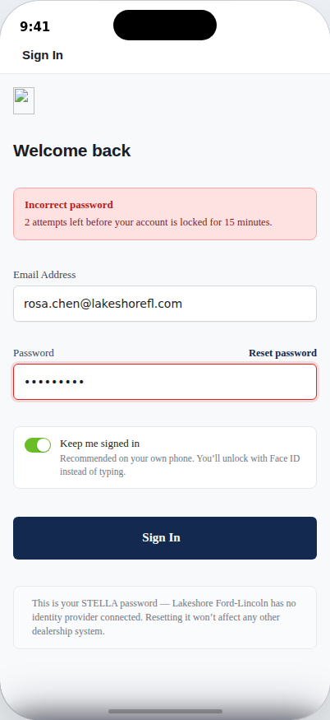
Incorrect password — live attempts-remaining counter, heading changes to “Welcome back.”
- Wrong password shows a live “X attempts left before your account is locked for 15 minutes” counter. If they lock themselves out, the wait is time-based — there's no support override to unlock it early in the current build, so tell them the exact wait time shown and to try again after.
- The eye icon on the password field toggles visibility — point customers to it before assuming a typing issue.
- “Keep me signed in” (on by default) is what enables Face ID unlock on that device going forward — if a customer says Face ID “never worked,” check whether this was left off during their last sign-in.

2.4 Forgot / reset password
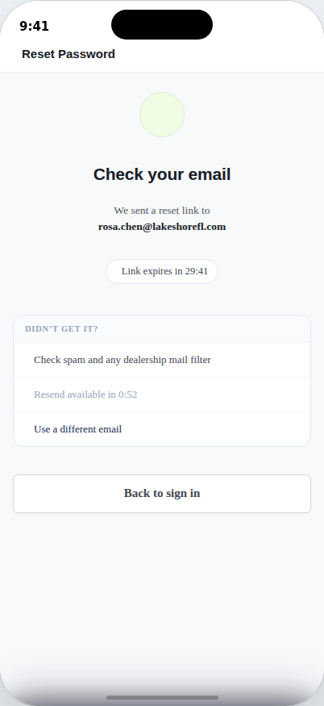
Reset link sent — 30-minute expiry and a short resend cooldown, both live countdowns.
- Only available for STELLA-password (non-SSO) accounts. An SSO user asking to reset their password should be redirected to their own company's password reset — STELLA has no password to reset for them.
- The reset link is valid for 30 minutes. If a customer says the link “didn't work,” check the time — it's most often expired, not broken.
- Resend has a short cooldown by design (visible on-screen) to prevent spamming their inbox — tell them to wait for the timer if they tap Resend and nothing happens.
- Tell customers to check spam and any dealership-wide mail filter first — the in-app hint already says this, but it's the #1 reason a reset email “never arrives.”
- For security, the same “check your email” confirmation is shown whether or not an account actually exists for that address — this is intentional, not a bug, if a customer says they “got the screen but not sure it's real.”

2.5 Face ID / biometric unlock
- Returning signed-in users land on a Face ID prompt — not the email screen — and this covers the large majority of app opens.
- “Use password instead” and “Switch account” both drop back to the email-first Launch screen — use these if Face ID isn't recognizing the customer, or if a different person needs to sign in on a shared device.
- Face ID can be turned off per-device from Profile & Account → Security — if it's not prompting at all, check that toggle first.

3. Insights tab (Service Dashboard)
The landing tab after every sign-in. Summarizes STELLA's call-handling performance for the selected date range.
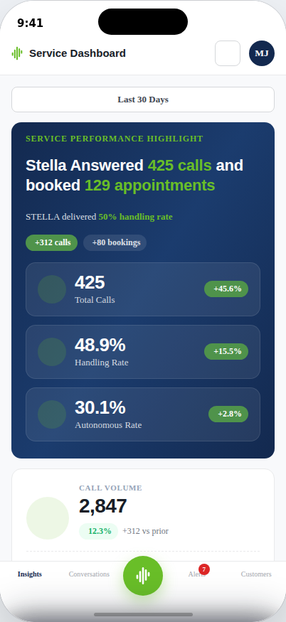
Service Dashboard — the default landing screen.
Metric | What it means
Total Calls | All inbound calls STELLA answered in the selected date range.
Handling Rate / Autonomous Handling Rate | Share of calls where STELLA completed the customer's goal or transferred per a dealer-defined rule — i.e., handled appropriately, whether or not a human ever joined.
STELLA Handling Rate | The narrower slice: calls STELLA resolved completely on its own, with no transfer or human intervention at all.
Appointments Booked / Booking conversion rate | Confirmed service appointments from calls, and what share of eligible calls converted to a booking.
Avg STELLA Talk Time | Average call duration — shown against the prior period so a drop reads as “faster resolutions,” not necessarily a problem.

Date range
- The pill at the top of the screen controls every number below it — always confirm what range a customer is looking at before troubleting a “numbers look wrong” complaint.
- Unlike Alerts (see Section 4), Insights has no lookback limit — Custom Range here can go back further than 30 days.

4. Alerts tab
A feed of calls that need a human follow-up, grouped by day, newest first.
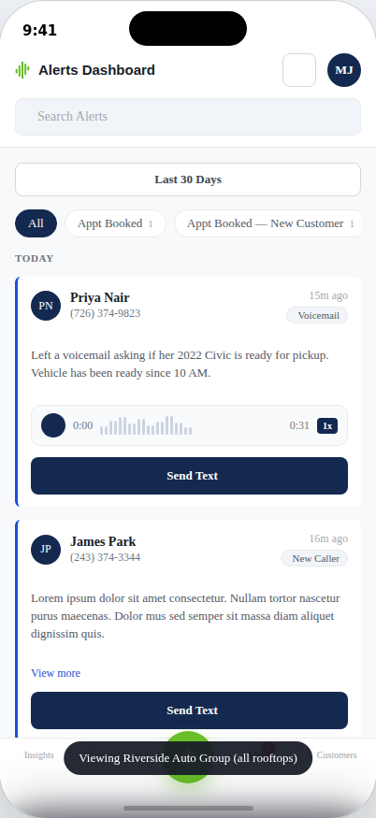
Alerts feed — filter pills, search, and inline voicemail playback.

Alert types
- Appt Booked, Appt Booked — New Customer, Booking Hangup, Cancelled Appt, Failed Transfer, Low CSAT, New Caller, Recall, Voicemail — plus a generic “Caller Ended Call” state for calls that ended without a clean outcome.
- Filter pills and the search box narrow the list live by type or contact name — no “apply” step.
- Voicemail alerts play inline with a scrubbable waveform. “Send Text” opens a real Conversation thread with that contact; “Call” is not yet wired to place an actual call in this build — see Section 9 before promising it works.
THE #1 ALERTS QUESTION: “WHERE ARE MY OLDER ALERTS?”
Alerts only ever shows the last 30 days of history, by design — an end-of-list note says so on the screen itself. Have the customer widen the date-range pill first; if they need data older than 30 days, point them to the Insights tab, which has no lookback limit, rather than trying to force Alerts to show it.

5. Conversations tab
A two-way SMS inbox, one thread per phone number — independent of whether that number matches a known customer record.
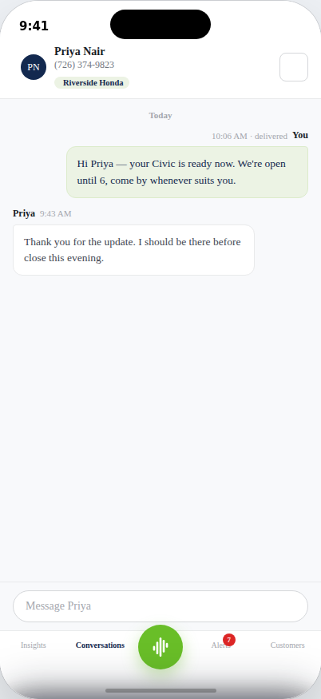
Thread detail — customer name and vehicle pulled in automatically when the number matches a record.

Starting a new conversation (Compose)
- Typing a name searches customer records live; typing a phone number checks it against every known contact.
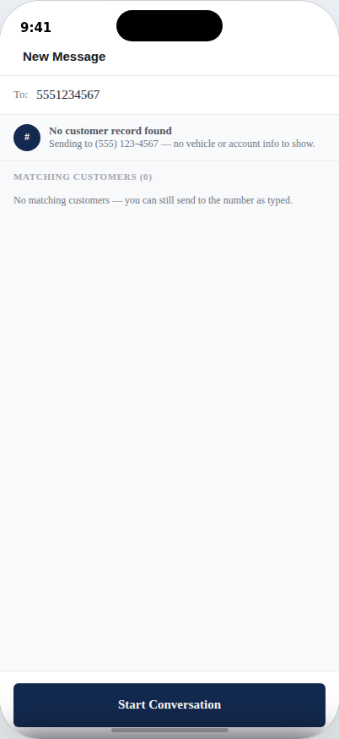
“No customer record found” — intentional, not an error. Staff can still text the number.
THIS IS EXPECTED BEHAVIOR, NOT A BUG
Texting a phone number with no matching customer record is allowed on purpose — it's labeled “No customer record found” and the thread still opens, just without vehicle or account context. This lets staff reach out to someone not yet in the system. Don't treat this as broken if a customer flags it.

Multi-rooftop / group view
- When a staff member is viewing the consolidated “all rooftops” group view (Section 8), each conversation shows a small location tag naming which rooftop it belongs to — this tag is hidden when viewing a single rooftop, since it would be redundant there.

6. Customers tab
The dealership's customer record list, grouped alphabetically like a native Contacts app.
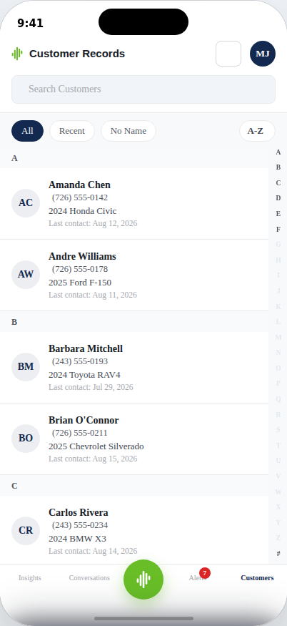
Customer Records — search, filters, A–Z sort and jump bar.
- Filters: All, Recent (last 5 by contact date), and No Name — caller-ID-only records with nothing to alphabetize, grouped under “#” at the end of the list regardless of sort direction.
- The sort toggle flips A–Z / Z–A; tapping a letter on the right-hand sidebar jumps straight to that group.
- Tapping any customer opens a real conversation thread with their vehicle and last-contact context already attached.
“SAVED” / STAR FEATURE IS NOT AVAILABLE YET
A star icon and “Saved” filter exist in the underlying data but are intentionally hidden in this release — there's currently no way for a customer to mark or save a record. If asked, this is a known future feature, not something to troubleshoot.

7. Profile & Account
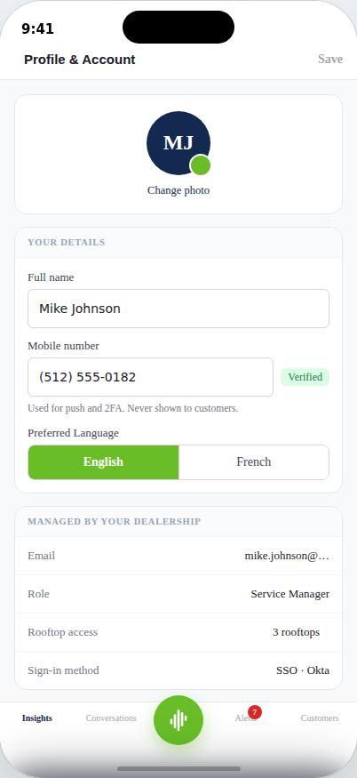
Profile & Account — editable fields vs. dealership-managed fields.

What the customer can change themselves
- Full name, mobile number, and profile photo (photo is stored on-device in this build).
- Preferred Language (currently English or French).
- Face ID unlock, on/off, per device.

What's locked / dealership-managed
- Email, role, rooftop access, and sign-in method are all provisioned by the dealer group through SSO and cannot be changed from the app — route any change request to their Group IT administrator, named on the Rooftop Access screen.
- “Active sessions” is currently a placeholder — there's no session management UI yet if a customer wants to sign a lost device out remotely. Escalate this specific request; see Section 9.

8. Notifications & Rooftop Access

Notifications
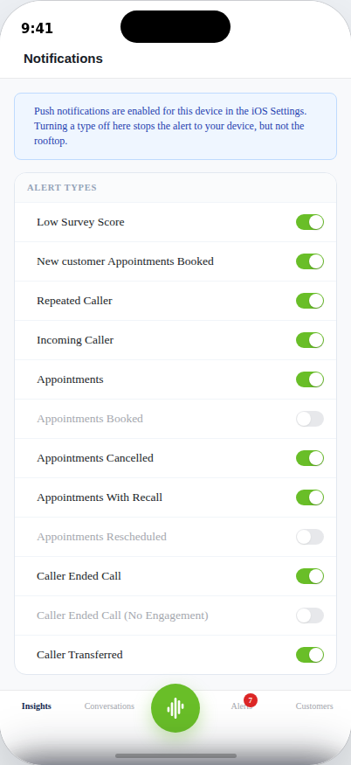
Notifications — 12 alert types; 3 are permanently greyed out.
- These toggles control which alert types push to this device — they do not change what the rooftop itself tracks or receives elsewhere.
- Push notifications must also be enabled for the app in the phone's own OS settings — if nothing is arriving at all, check that first before touching in-app toggles.
WHY ARE 3 TOGGLES GREYED OUT?
Appointments Booked, Appointments Rescheduled, and Caller Ended Call (No Engagement) are permanently disabled and labeled “not configured for this rooftop.” This is a dealership-level configuration gap, not a bug the customer can fix from their phone — if they want these enabled, escalate to confirm whether that rooftop's configuration supports them.

Rooftop Access & switching
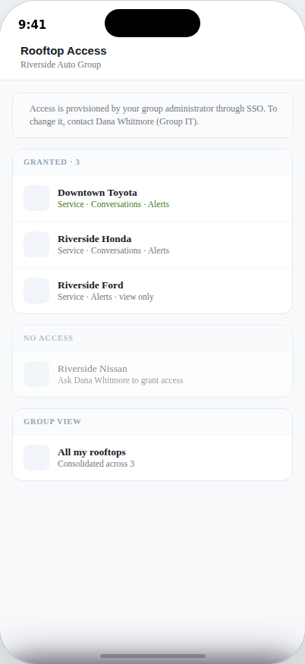
Rooftop Access — read-only; changes route to the group's IT administrator.
- This screen is read-only — it shows what a staff member currently has access to, but changing it requires their Group IT administrator (named on-screen).
- To actually switch which rooftop they're viewing day-to-day, direct them to the building icon on Insights, Alerts, or Customers — that opens “Switch Rooftop,” which includes both individual rooftops and a consolidated “all rooftops” group view.
- Note: the “All my rooftops” row at the bottom of the Rooftop Access screen itself is currently a placeholder — send customers to the Switch Rooftop sheet instead, where the equivalent consolidated view actually works.

9. Quick-reference FAQ
Customer says / asks | What's happening / what to tell them
“I can't sign in at all” | Ask what they see after entering their email. A password field they don't recognize means their domain isn't SSO-connected — see Section 2.1–2.3. A blank/frozen screen is an app issue — escalate with device model and OS version.
“It says I have no rooftop” | Identity confirmed, access not provisioned. Have them use “Request access” on that screen; if unresolved after a business day, escalate with the reference code shown on their screen.
“My account is locked” | STELLA-password accounts only. The wait is time-based (shown on screen, typically 15 minutes) — there is no manual unlock in the current build.
“The reset email never came” | Have them check spam and any dealership mail filter first. Confirm which account type they have — SSO users need their company's own reset, not STELLA's.
“I can only see 30 days of alerts” | By design. Point them to Insights for longer lookback, or widen the Alerts date range up to the 30-day cap.
“I texted a number that's not showing customer info” | Expected — “No customer record found” still lets the thread send. Not a bug.
“Can I call a customer directly from the app?” | Not yet functional in this build — see known limitations (Section 10) before confirming a timeline.
“Why can't I turn on this one notification type?” | Check if it's one of the 3 permanently-disabled types (Section 8) — that's a rooftop configuration gap, not a device issue.
“Can I save/star my favorite customers?” | Not available yet — planned, not broken.
“I need to change my rooftop access” | Route to their Group IT administrator (named on their Rooftop Access screen), not STELLA Support directly, unless there's evidence the request was already made and ignored.

10. Known limitations — don't promise these
These are current-build gaps, confirmed against the app itself. Acknowledge them as “not available yet” rather than troubleshooting them as errors, and don't commit to a specific ship date unless product has given you one.
Feature | Current state
Calling a customer from Alerts | Shows a confirmation toast only — does not place a real call.
Voice messages in Conversations | Mic button shows “coming soon.”
Saving / starring a customer | Hidden — no way to mark a customer as saved.
Privacy & Data / Help & Support (Account menu) | Placeholder — no content behind these yet.
Active sessions (Profile & Account) | Placeholder — no remote sign-out of other devices yet.
“All my rooftops” row (Rooftop Access screen) | Placeholder on that specific screen — the equivalent consolidated view does work from the Switch Rooftop sheet (building icon).
Quiet Hours / notification Scope | Removed from this release — not currently configurable at all.

11. Escalation path
Situation | Route to
Rooftop access / provisioning requests | The customer's own Group IT administrator first (named in-app on the Rooftop Access / No-Access screens); escalate to STELLA Support only if that request has gone unanswered.
Suspected account lockout or reset issue beyond what's described here | STELLA Support — include the account email, dealership, and (if shown) the on-screen reference code.
App behavior that doesn't match this playbook | STELLA Support/Engineering — include device model, OS version, app build number (shown at the bottom of the sign-in screen and the Account sheet), and exact steps to reproduce.
Feature requests (call-from-app, voice messages, saved customers, session management, Quiet Hours) | Log as product feedback — these are roadmap items, not defects. Do not commit customers to a timeline.
ONE LAST REMINDER
“Customer” throughout this document is the dealership staff member using Insights Mobile — always confirm you're troubleshooting the app itself, not the underlying phone system or the driver's actual service visit, before escalating.

